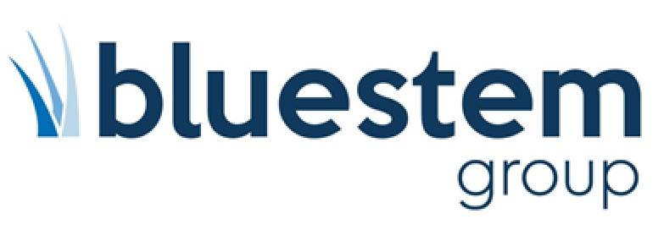
Job Description
Key Accounts Manager – Midlands, Mid/North Wales, Derbyshire, Leicestershire

Company Overview
Established in 1988, Bluestem Group is one of the UK’s leading manufacturers and distributors of electrical appliances and household goods; operating in various sales channels such as independent and national retail, wholesale and B2B. We are an award-winning business with a strong focus on operational excellence and quality innovative products. Our people are the key to our business success, providing unrivalled support and high levels of service to our customers. We are dedicated to providing our team with a great place to work, where everybody feels valued.

Hours: |  | Reports To: | Sales Manager
Department: | Sales | Location: | Field
As the Key Accounts Manager you will be part of a team of field sales professionals and will be responsible for developing relationships with both new and existing customers to maximise profitable sales across both our existing range or products and continuous cycle of new product development opportunities.
Also responsible for two of our industry Buying Groups – with a focus on relationship development, and member engagement.
With ambitious business growth plans, it’s vital that you develop a constant pipeline of new sales lead opportunities.
The role is remote, and field based, with occasional meetings at our head office in Ipswich.
KEY RESPONSIBILITIES
- Developing relationships with existing customers to maximise profitable sales across our existing range of brands and products
- Regular communication to Buying Groups ensuring fully up to speed with all promotions, new products launched, plus managing any Group trade shows
- Develop a constant pipeline of new sales lead opportunities, generating and securing new business
- Selling multiple brands and products across several sectors
- Meeting or exceeding sales targets
- Compose Area Journey Plan to ensure coverage of relevant trading accounts and new business activity
- Plan monthly diary to maximise selling time with customers
- Ensure brand presentation information is up to date and current
- Review and analyse business reports to understand region activity, challenges and success
- Process all orders to sales office
- Communicate with internal business colleagues and external Sales Team
- Work with business best practice protocols

ESSENTIAL SKILLS
- Proven sales experience in selling multiple products across several sectors
- Ability to communicate at all levels
- Must have willingness to travel and work remotely
- Full clean driving licence
- Proven experience of account management and relationship development
- Target driven and ability to work independently
- Excellent computer skills and experience in using databases
- Experience in pro-actively seeking out and securing new business
DESIRABLE SKILLS
- Experience of the electrical / domestic appliance industry

